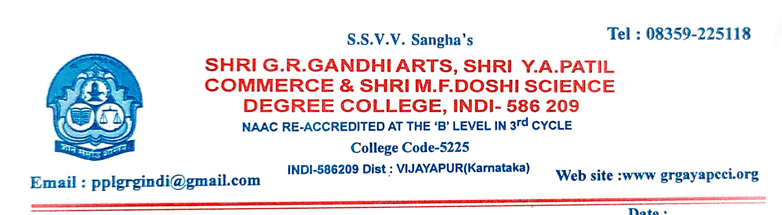
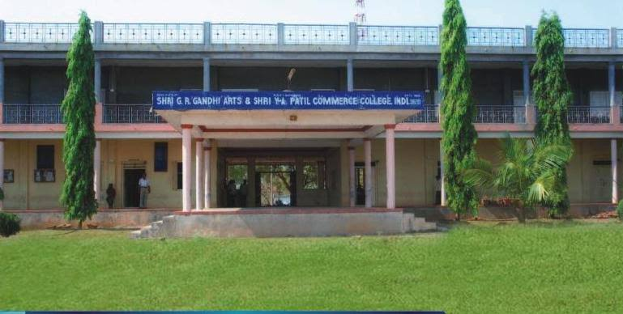
BEST PRACTICES 2021-22

CRITERION VII - INSTITUTIONAL VALUES AND BEST PRACTICES
7.2 - Best Practices
7.2.1 - Describe two best practices successfully implemented by the Institution as per NAAC format provided in the Manual. Best Practices 2020-21
2021-22 BEST PRACTICE – 1
1. Title of the Practice: Learning Through Competition
2. Objectives of the Practice :
The objective of the practice is to provide platform for students to demonstrate the talent, a stepping-stone to achieving greater things in life. In turn the rewards of student competitions can help to achieve the educational and professional goals.
❖ To develop the design skill and problem solving capabilities.
❖ To improve leadership quality and management skills.
❖ To improve decision making ability.
3. The Context :
The institute consistently provides motivation, support, and platform for students to inculcate leadership and multidisciplinary skills for enrichment of competency. The institute provides necessary financial assistance and resource every year to strengthen such activities. Due to regular schedule of academics selecting the right candidates for the activity is really a tough task due to shortage of time. In spite of busy academic schedule and shortage of time we had to put in extra hours for competition. To ensure the talents of students by held to these competition. To develop speaking and writing skills in students.
4. The practice :
All students are informed well in advance by circulating notice regarding competition. All competition was done under the cultural department. Every competition was assigned to specific faculty. Under the competition will designed a certificates, cash prizes. Among these competitions and winners are got cash prizes.

5. Evidence of success : The faculty are strives hard to make a position for themselves in every field. The cultural committee conducts various activities which is appreciated by the various competitions.
- 75th Independence Day :
Essay : Role of revolutionaries in freedom moment on 12.08.2021
Winners :1.Sonali Ghodk 2.Pavitra Chavan 3.Ravi Putani
- Kannada Rajyotsva : competitions on 29.10.2021
1.Singing:- Bhavagee..1]Soni.Salimath,2]Aishwarya.Kambar,3]Kamanagoud biradar
2.Speech : Kannada Nadu Nudi
1.Soni salimath , 2.Jyoti Walikar 3.Shantagoud Biradar
3.Essay : Karnatak Ekikarana
1.pooja barado 2.Bhagyashri Biradar 3.Lakshmi ummarji
4.Rangoli : Kannada Nela,Jala,Bhashe
- Vishwa Manav Dinacharane : competitions on 27.12.2021
1.Singing : Bhavageete of Kuvempu
1]Soni Salimath , 2]Aishwarya Kambar ,3] Swati Bhavikatti
2.Speech : Nanna Kuvempu
1]Nikkat Tennalli 2] Shantagoud Biradar ,3]Jyoti Walikar
3.Essay : Kannada sahityakke kuvempu koduge
1]Lakshmi Talakeri 2] Sonali Ghodake 3] Sapna Deganva
4.Rangoli : Kannada sahitya
- National Science Day : competitions on 26.02.2022
Quiz competition ,Science modules
6. Problems encountered and resources required : The main problem was due to covid busy academic schedule and shortage of time we had to put in extra hours for competition. Need some more time for do activities.

Essay Competition on Role of revolutionaries in freedom moment about
75th Independence Day :
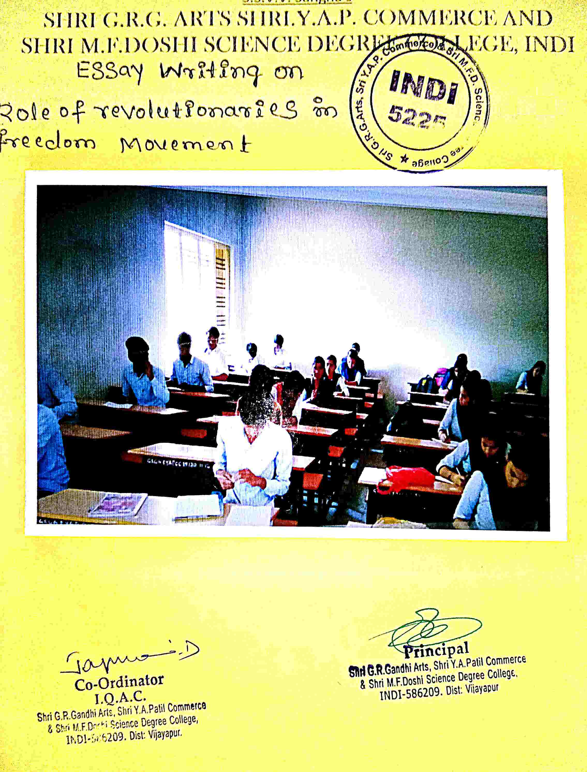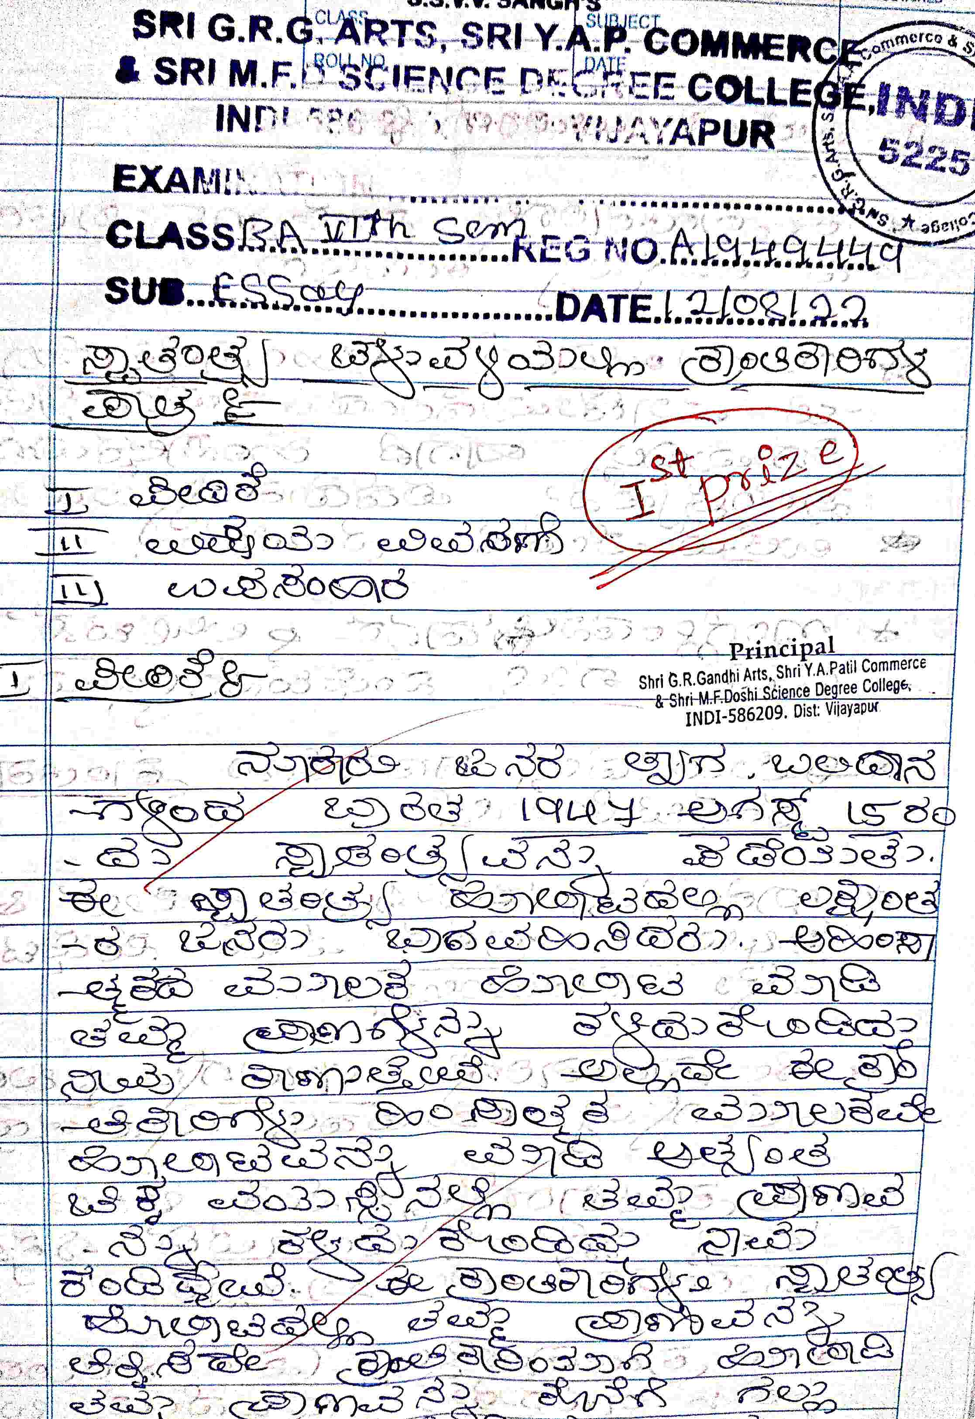

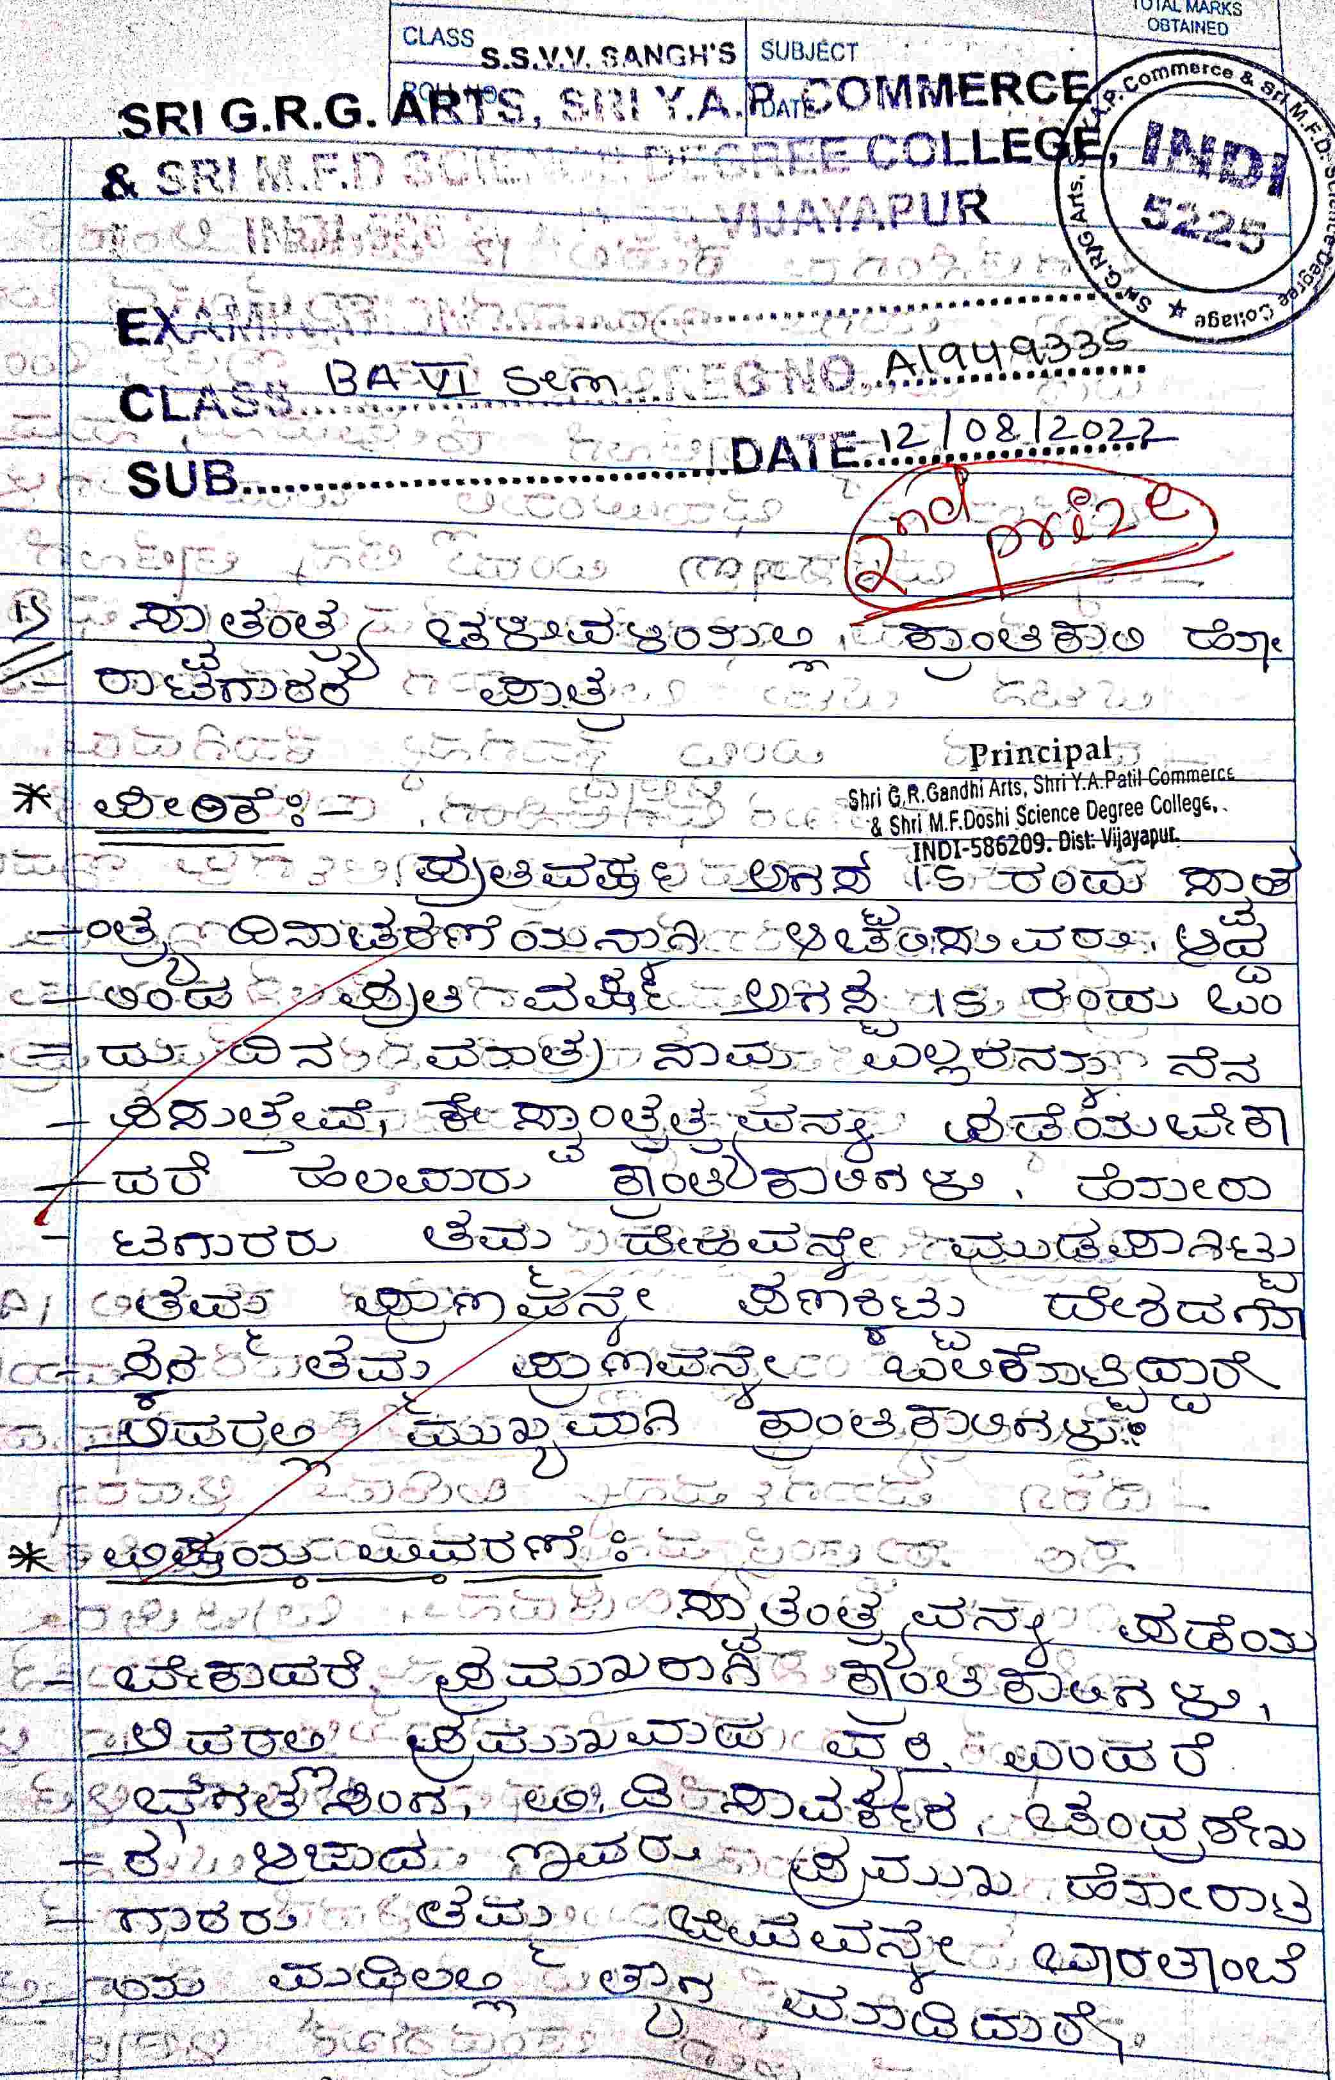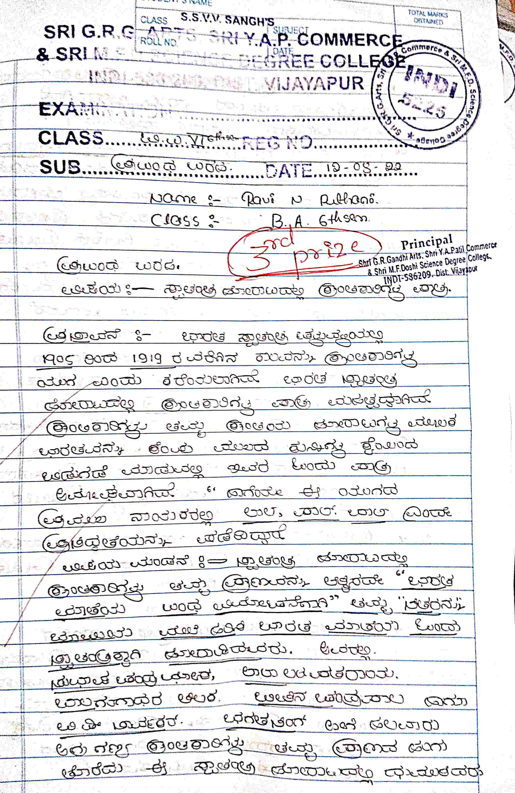

Essay on Karnatak Ekikarana about KANNADA RAJYOTSVA
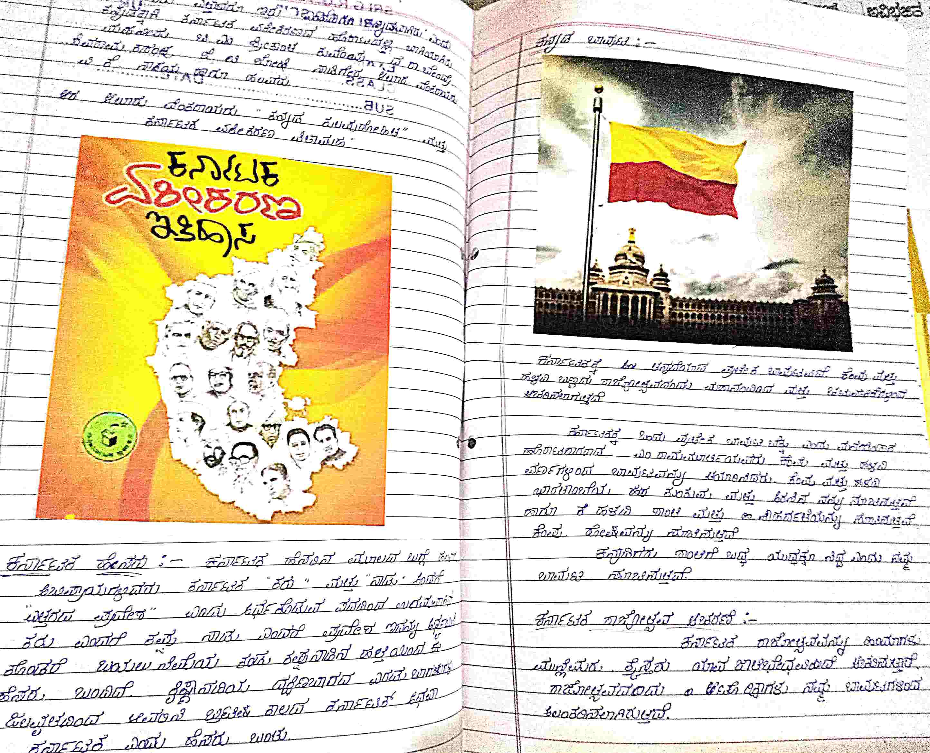

ESSAY,QUIZ,SPEECH COMPITITION ON THE OCCASION OF VISHWA MANAV DAY
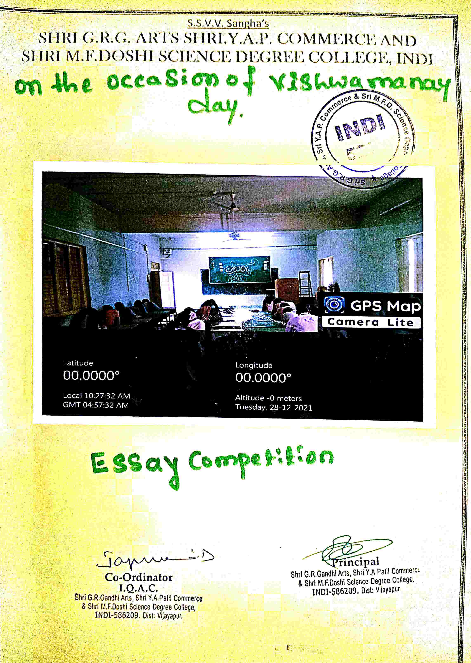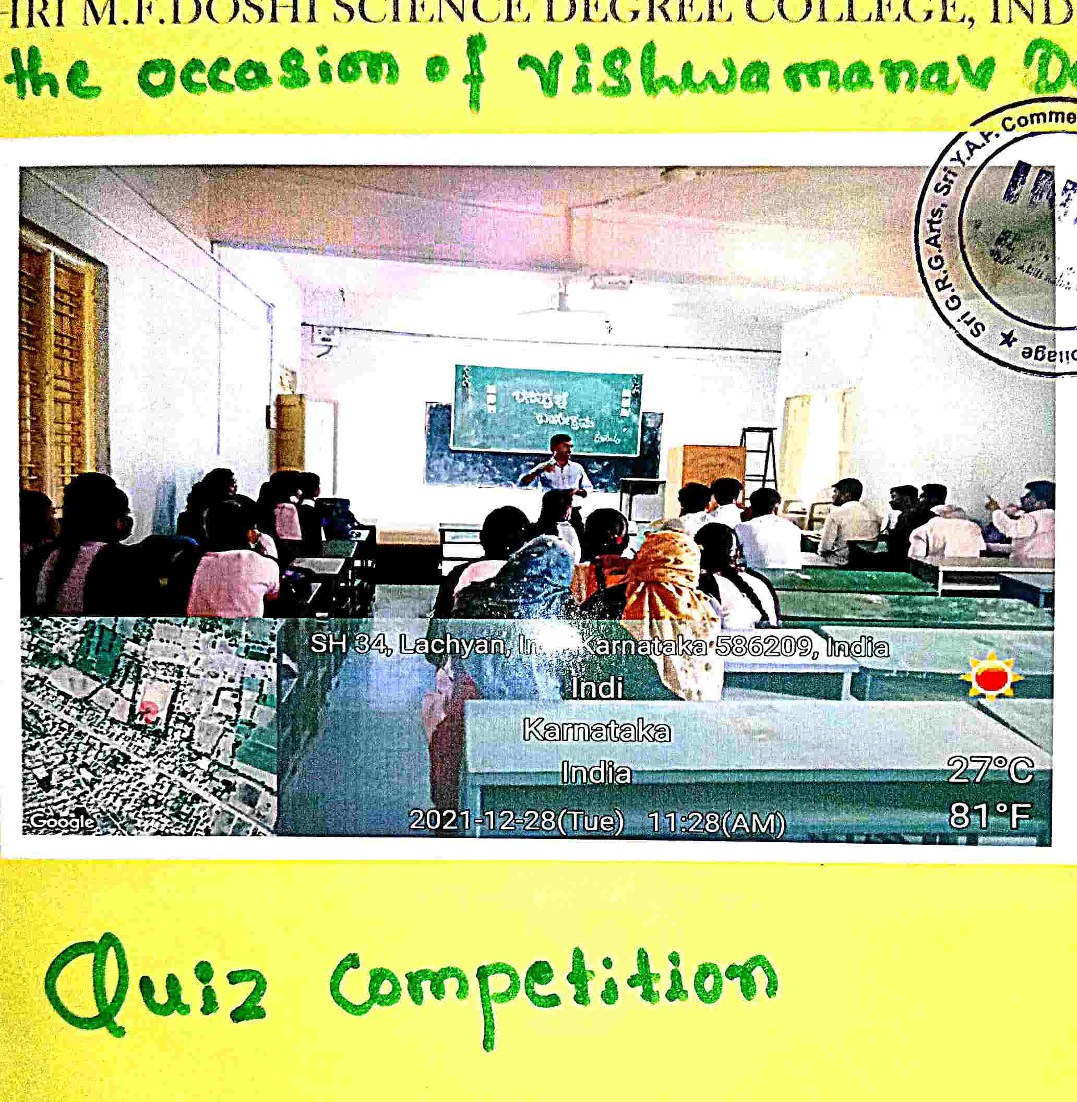

VISHWA MANAV DAY NATIONAL SCIENCE DAY
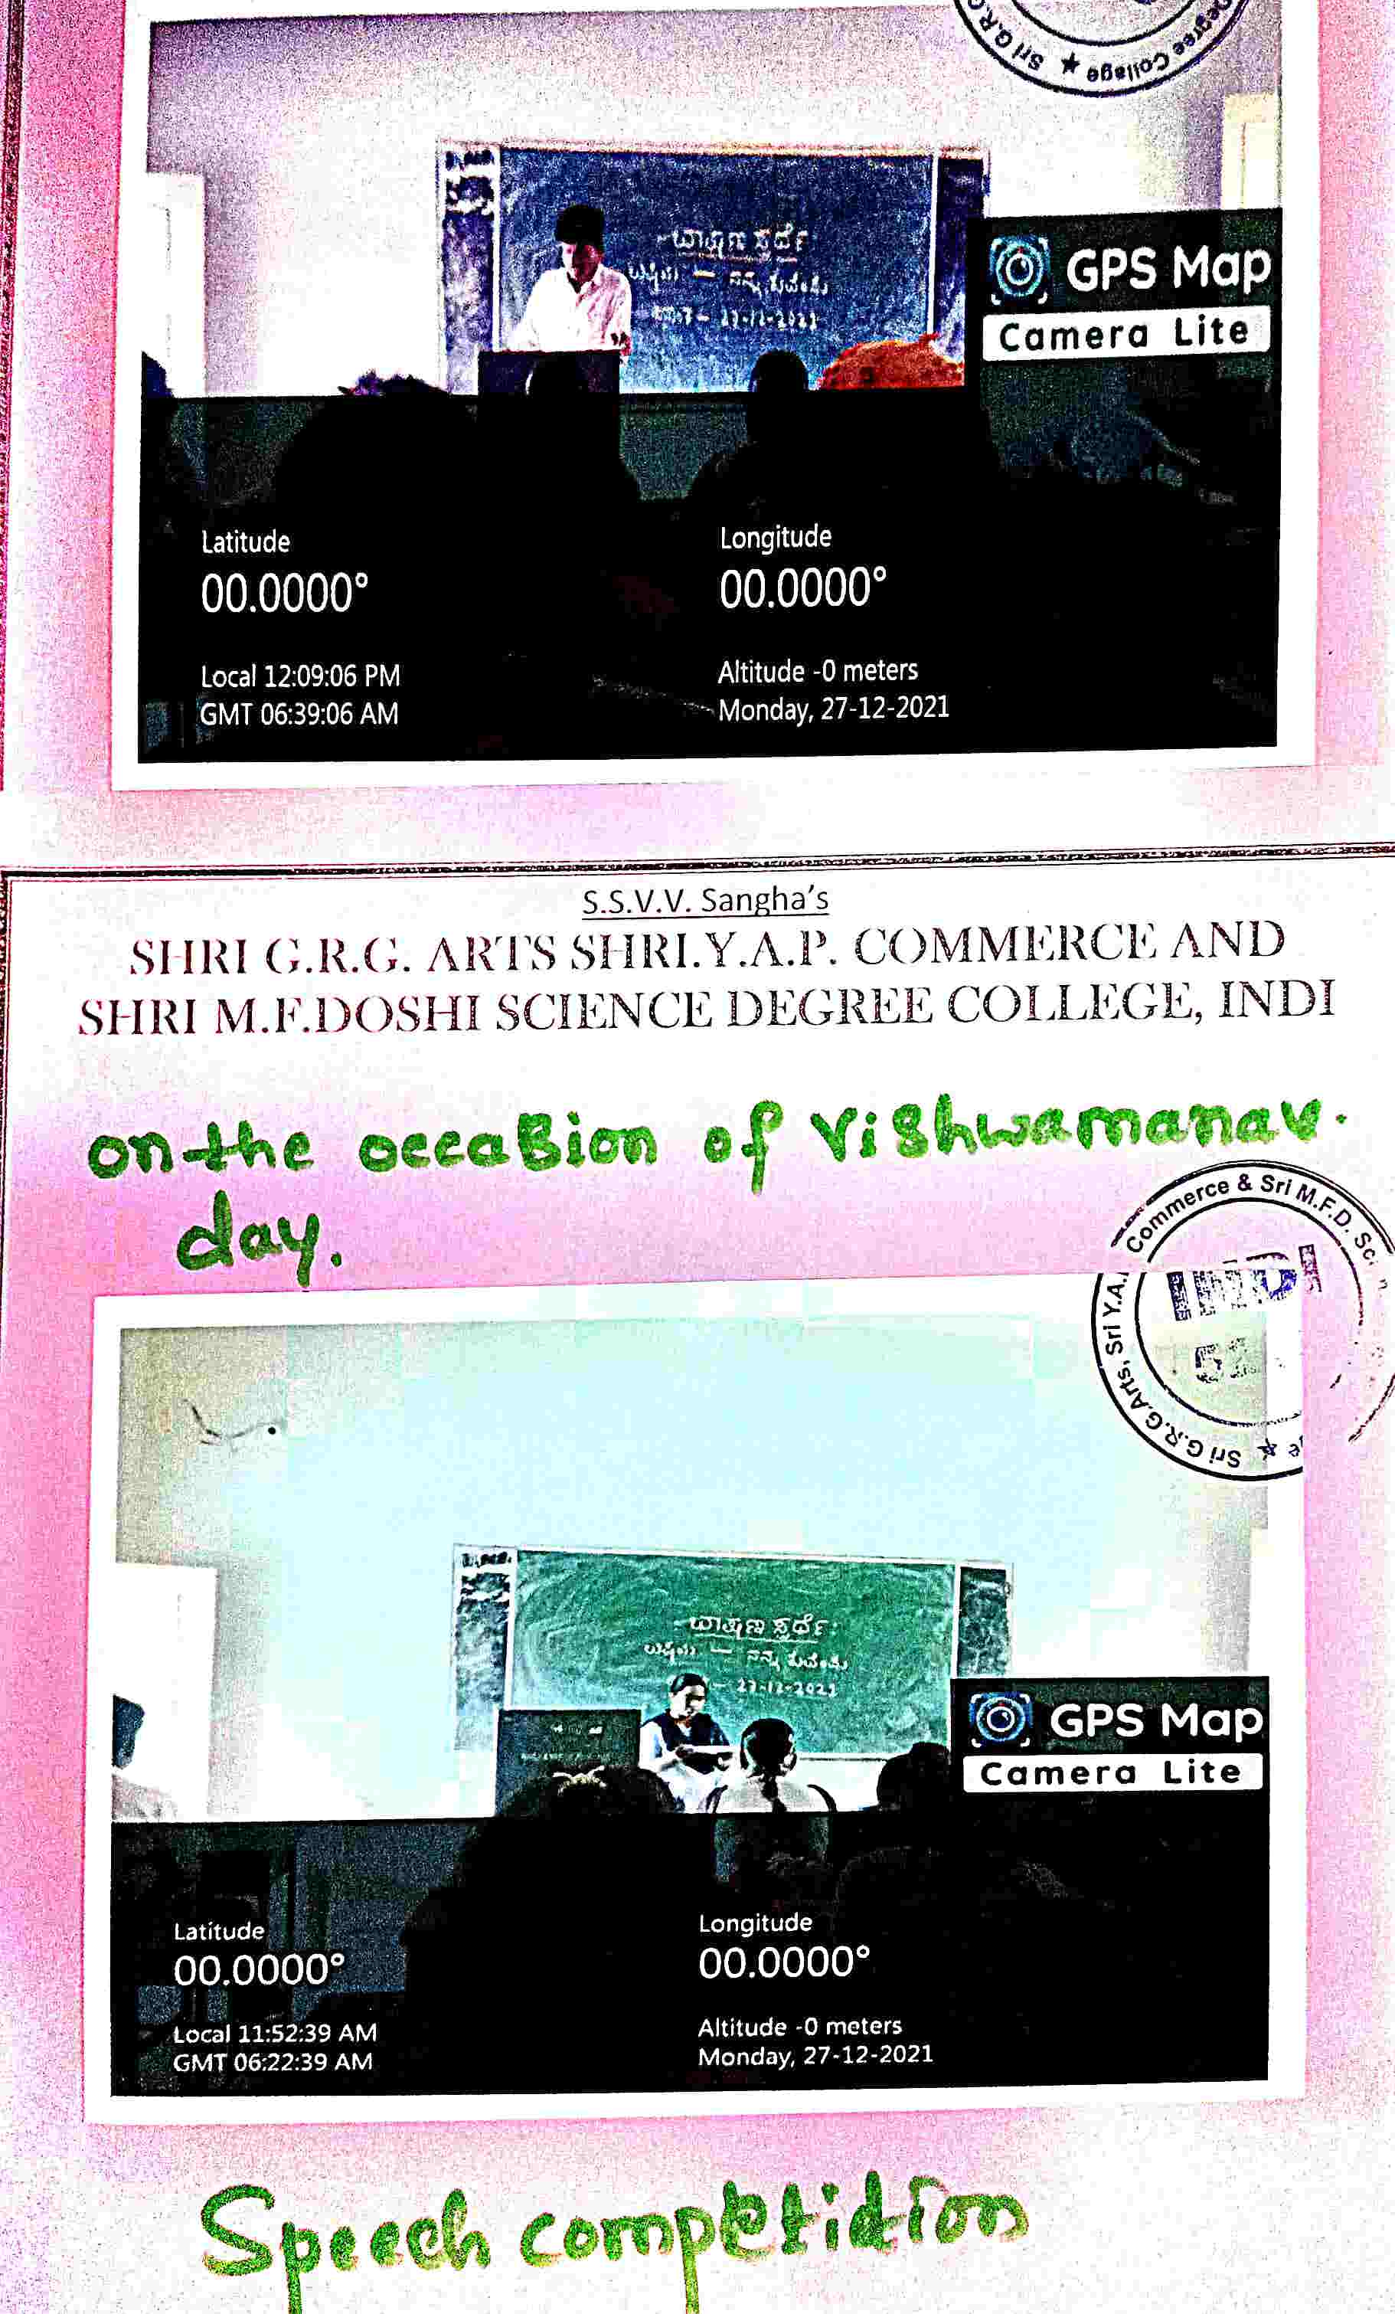
2021-22 BEST PRACTICE – 2
1. Title of the Practice: Campus Recruitment in Institution
2. Objectives of the Practice :
It’s a very popular method/ term which is been used in today’s time for recruiting fresh graduates/ post graduates by the small, medium and large organizations. In campus recruitment companies visit some top technical and professional institutes to hire young and well-groomed crowd. It’s different from traditional methods where job seekers approach employers in this process the employers themselves visit various high profile institutes in search of energetic upcoming talent. The major objective of campus recruitment is to identify the talented and qualified students before they complete their education, as this process reduces the time for an industry to pick the candidates according to their need.

3. The Context :
Campus recruitment is the process by which the corporate recruit students who are about to graduate from the educational institutions. The selection process varies from company to company, may have pre placement talk, written test, group discussion and interviews. Students and the recruiting companies are considered to be the major stake holders in a campus recruitment process. Entry level salaries and the recruitment season are considered to be the important parameters in a campus recruitment process. The study analyses the perception of the students and the human resources (HR) managers on the entry level salaries and the recruitment season.
♣ To know about various companies using campus recruitment method and finding theirstrategies.
♣ To study the recent trends and challenges in campus recruitment method.

4. The practice :
Campus placements can be nerve-wracking. Job hunting has always been challenging, especially for freshers. The uncertainty of finding a job without experience seems tricky as you may not know where to start.
This is why all college students want to give their best shot when it comes to campus placements.
1.Apply with clear resume.2.Research the Companies 3.Prepare for interview questions. 4. Practice for all kind of interviews
5. Evidence of success :
nowadays, due to a high level of competition coming from everywhere. So doing well at the entrance interview is extremely important. In our institute heired 24 top companies such that in the manner of these companies 1284 students and other youths got selected.

6. Problems encountered and resources required :
The problem was Campus hiring process differs from company to company so students and youths got confused. That’s why need to be same process

NEWS PAPER REPORT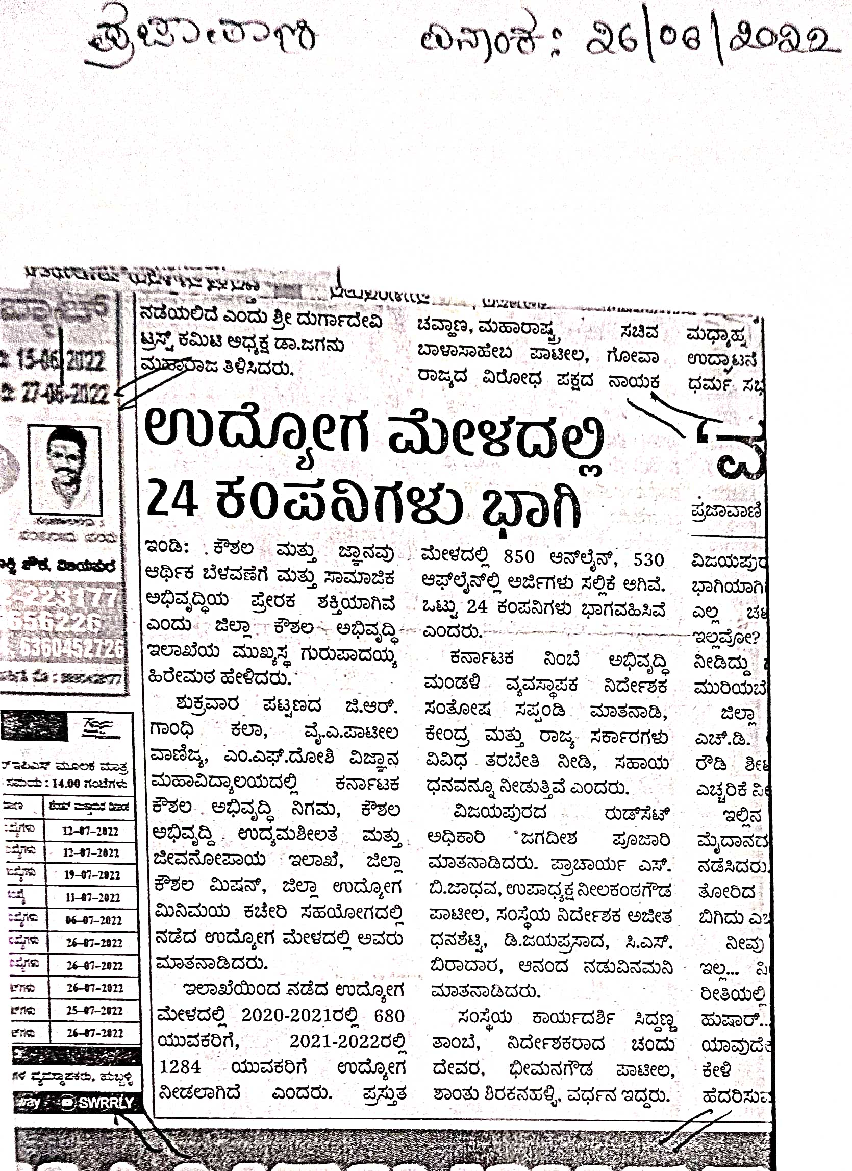
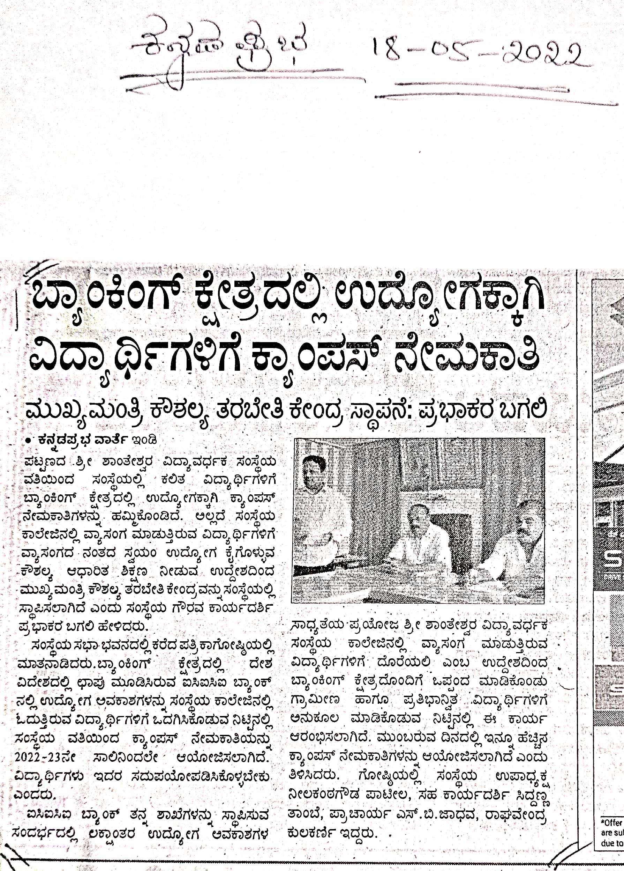

COMPANIES DETAILS REGISTRATION
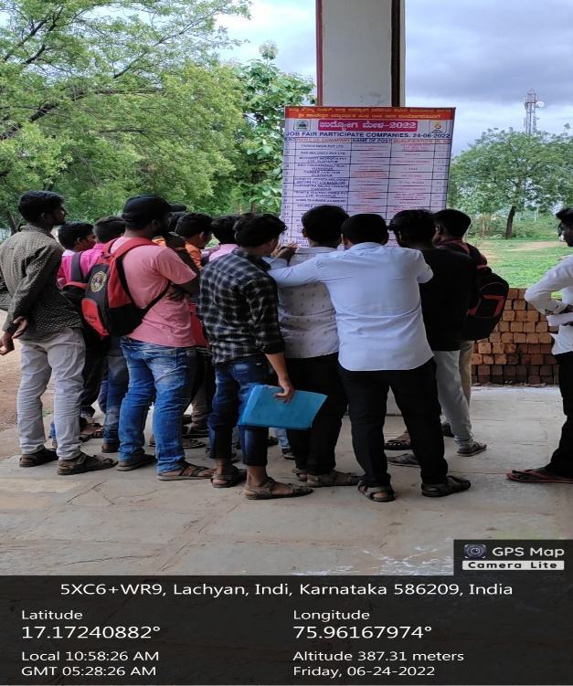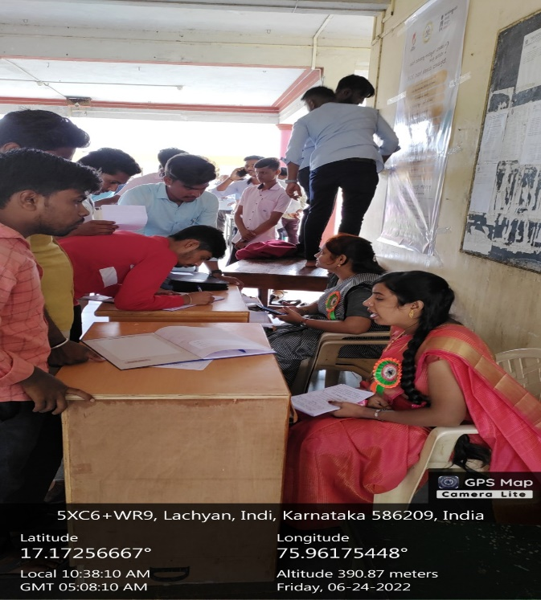

INTERVIEW
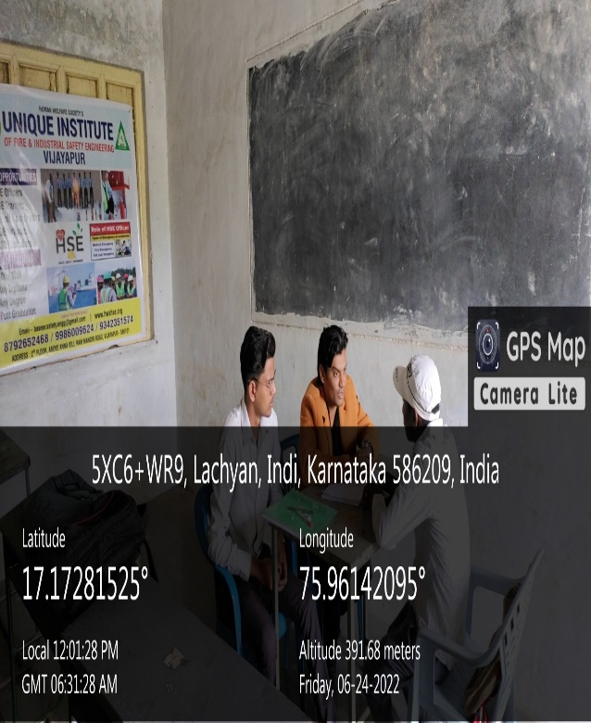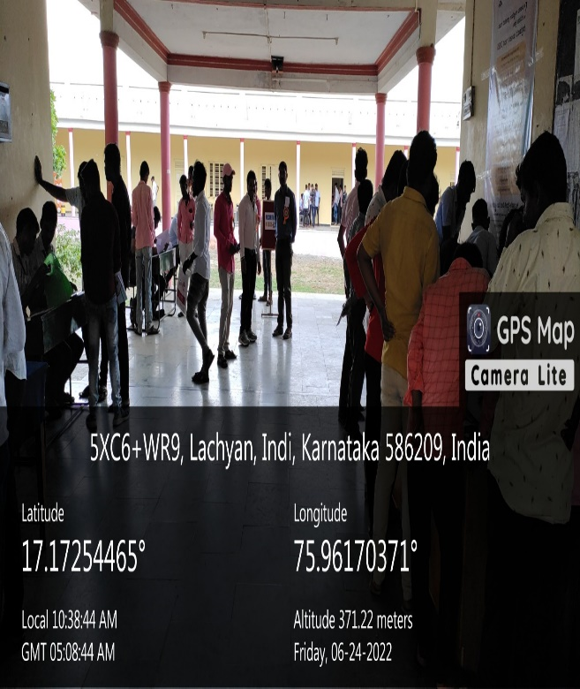

SELECTED CANDIDATE LIST
